📘 DevOps Learners Assignment
Topics Covered: Git, GitHub, AWS EC2, Load Balancers, S3 Buckets & Static Websites, Shell Scripting (Nginx Setup), AWS AMIs & Volume Snapshots

Section 1: Git and GitHub (6 Questions)
- What is the difference between Git and GitHub? Explain with examples.

Feature | Git | GitHub
Define | A version control tool | A code hosting platform
Usage | Tracks changes locally | Shares code online
Works offline? | Yes | (needs internet)
Installed on | Your computer | Used via web browser
Main purpose | Save and manage project history | Collaborate and store Git projects online
Example command | git commit -m "message" | git push origin main

- Write the Git commands for the following scenario:
  - Initialize a new repository
Ans:git init
  - Add all files to the staging area
  - Ans: git add .
  - Commit with a message "Initial commit"
  - Ans: Git commit -m “intial commit”
  - Push the code to a GitHub repository.
Ans: git remote add origin<url>
git push -u origin main
- How would you resolve a merge conflict in Git?
  - Provide a simple situation where conflicts occur and how to solve them.
Pull the latest changes:
First, make sure your branch is up-to-date with the remote repository.
Run a git pull command to fetch and merge the latest changes from the main branch into your current branch.
Git detects the conflict:
If there are conflicting changes, Git will stop the merge and tell you that there's a conflict in one or more files. It will also mark these files as "conflicted."
Open the conflicting files:
Look for the files that have conflicts. Open those files in your text editor or IDE. Resolve the conflict:
You’ll need to decide which code to keep. You can either:
- Keep your changes
- Keep the changes from the branch you’re merging
- Combine both changes manually if needed.
Stage the resolved files:
Once you’ve fixed the conflict, save the file.
Then, run git add <filename> to stage the file. This tells Git that the conflict has been resolved.
Commit the merge:
Now, commit the changes with a message that describes the conflict resolution. For example:
git commit -m "Resolved merge conflict in <filename>"
Push the changes:
Finally, push the resolved changes back to the remote repository with git push origin <branch-name>.

- Explain the purpose of .gitignore file with an example.
Ans; The .gitignore file tells Git what NOT to track.It’s used to ignore files or folders that you don’t want in your Git repo.
Ignore node_modules folder—--node_modules/
Ignore —--log files*.log
Ignore —--system files.DS_Store
Ignore —----environment config.env
- Explain the differences among the following Git operations:
  - git pull:Fetches + applies the latest changes to your code
  - git fetch :Downloads new changes from GitHub, but doesn't apply them
  - git clone:copies an entire repo from GitHub to your computer.
- What are the different types of Git reset (--soft, --mixed, --hard) and what does each one do?
ANS : git reset --soft
- Moves the HEAD to a previous commit ,but it keeps your changes in the staging area.
- to use: If you want to "uncommit" but keep the changes ready to commit again.
Example:
You made a commit and want to uncommit it but keep the changes for a new commit

git reset --mixed:Moves the HEAD to a previous commit and unstages the changes. It doesn’t touch your working directory, so your changes are still there, but they’re no longer staged.

to use: If you want to undo a commit and unstage the changes but keep them in your files.
Example:
You want to undo the last commit but unstage the changes

git reset --hard: Moves the HEAD to a previous commit and removes all changes (both staged and in your working directory). It’s like a complete reset.
- When to use: If you want to completely undo a commit and discard all your changes (both staged and unstaged).
Example:
You want to undo the last commit and completely discard the changes:

Section 2: AWS EC2 and Load Balancers (4 Questions)
- Describe the types of EC2 instances available (On-Demand, Reserved, Spot, Savings Plan) and explain the differences among them.

- On-Demand: You pay for what you use with no commitment. Best for flexible and short-term needs.
- Reserved: You commit to using instances for 1-3 years to get big savings. Ideal for steady, predictable workloads.
- Spot: You bid on unused AWS capacity and can get significant discounts. Good for flexible tasks that can handle interruptions.
- Savings Plan: You commit to a certain usage level across different services (EC2, Lambda, etc.) for a discount. Flexible but requires a long-term commitment.

- What is an Elastic Load Balancer (ELB)?
  - Name different types of load balancers AWS offers and when to use them.
Ans : Application load balancer: Routes HTTP and HTTPS traffic based on content, such as URL path or host. Best for web applications that require advanced routing, such as handling requests to different parts of a site (e.g., /images vs. /api).
Network load balancer :Routes traffic based on IP address and port. It can handle millions of requests per second. Ideal for high-performance, low-latency applications, like real-time applications (e.g., gaming, financial services) or handling TCP/UDP traffic.
Classic Load Balancer: The older generation of load balancer that supports both HTTP and TCP traffic.Use for basic use cases or legacy applications that don’t require the advanced features of ALB or NLB.
Gateway Load Balancer: Routes traffic to virtual appliances for tasks like network security, monitoring, and more.Use when you need to route traffic to appliances like firewalls, intrusion detection systems, etc., for specific networking tasks.
9.Explain how you would configure a load balancer to distribute traffic between two EC2 instances hosting the same website.
Ans: Set up two EC2s → Create a target group → Attach to a load balancer → Set up listener → Done

10.If one EC2 instance under a load balancer becomes unhealthy, what happens automatically? How can you monitor this?
If an instance becomes unhealthy, the load balancer automatically stops sending traffic to it and redirects traffic to healthy instances, while you can monitor the instance health using health checks, the AWS Console, CloudWatch metrics, and access logs.

Section 3: S3 Buckets and Static Websites (3 Questions)
- How do you create an S3 bucket and upload a file using the AWS Management Console?
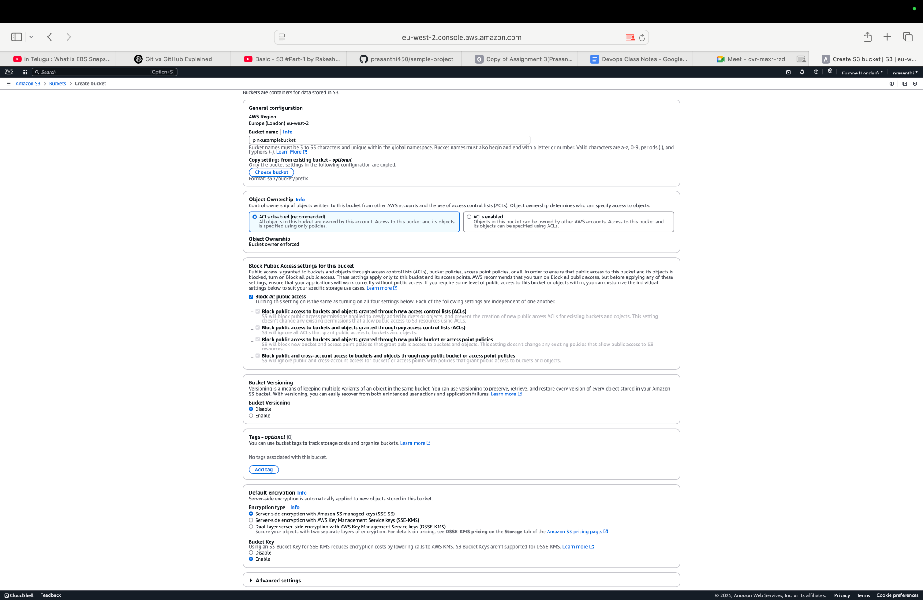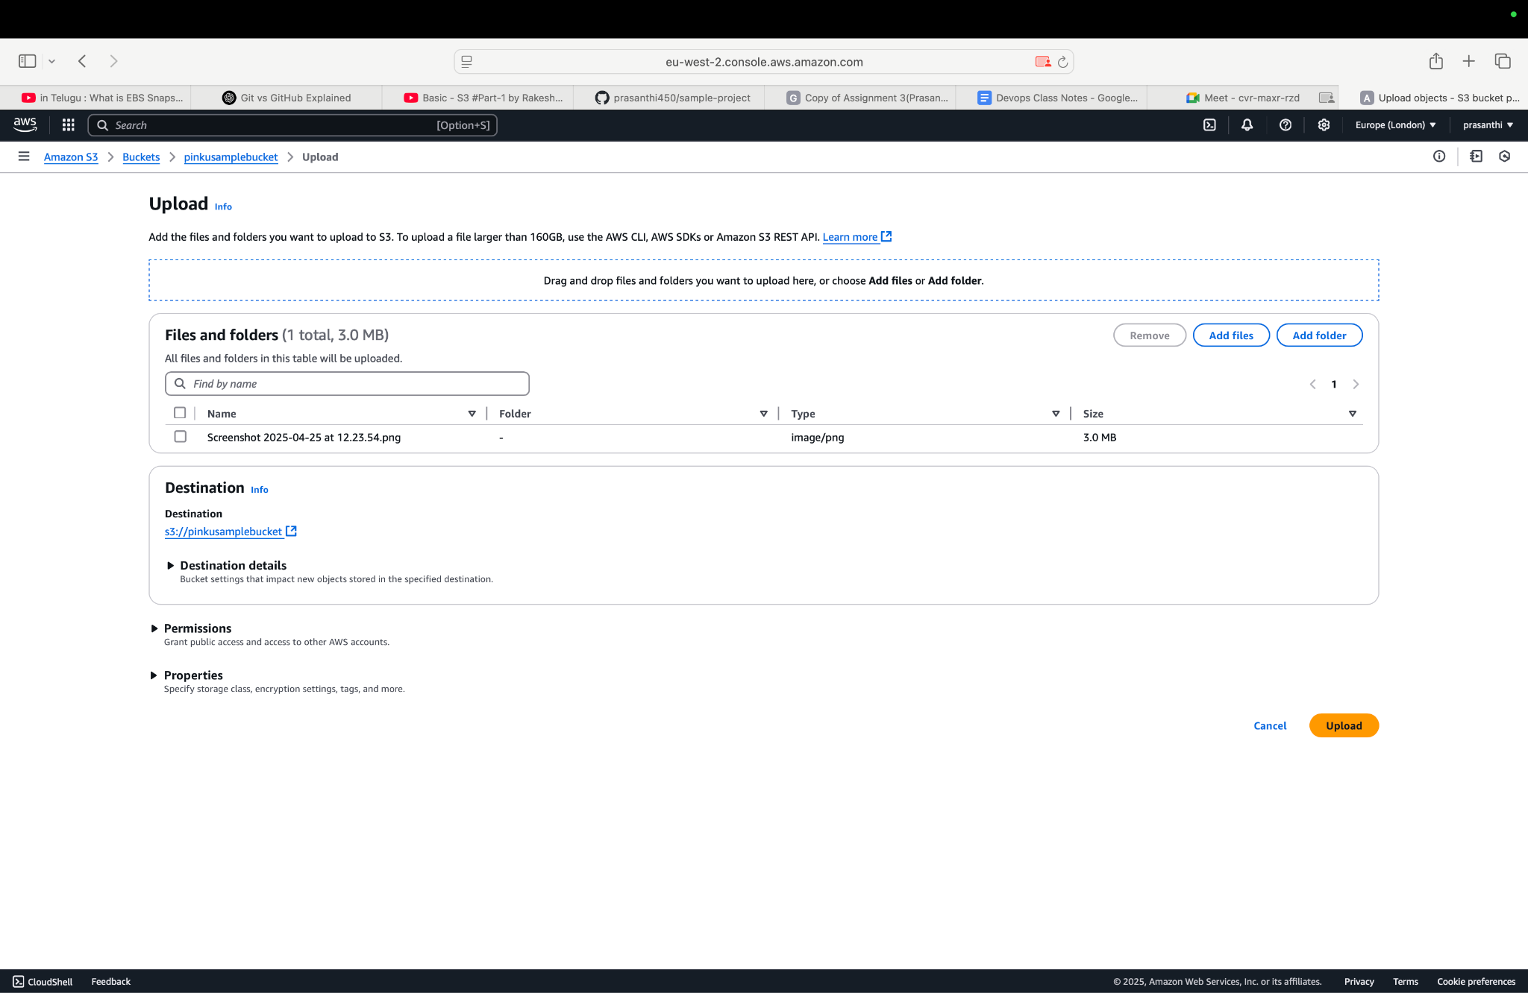
- (List the important settings like region, permissions.)
REGION : Choose where (which AWS region) your bucket will physically store the data.
PERMISSIONS: Decide who can access the bucket (you, your team, the public, etc.).
BUCKET POLICY : Special rules (written in JSON) that allow or deny access to your bucket or objects.
VERSONING: Keeps multiple versions of a file (good for backup and recovery).
SERVER SIDE ENCRYPTION: Encrypts your files automatically for better security.
PUBLIC ACCESS SETTINGS : Settings to block or allow public access to your bucket — very important for security!
12. How would you host a static website using an S3 bucket?
- (Mention website hosting option, bucket policy for public access.)
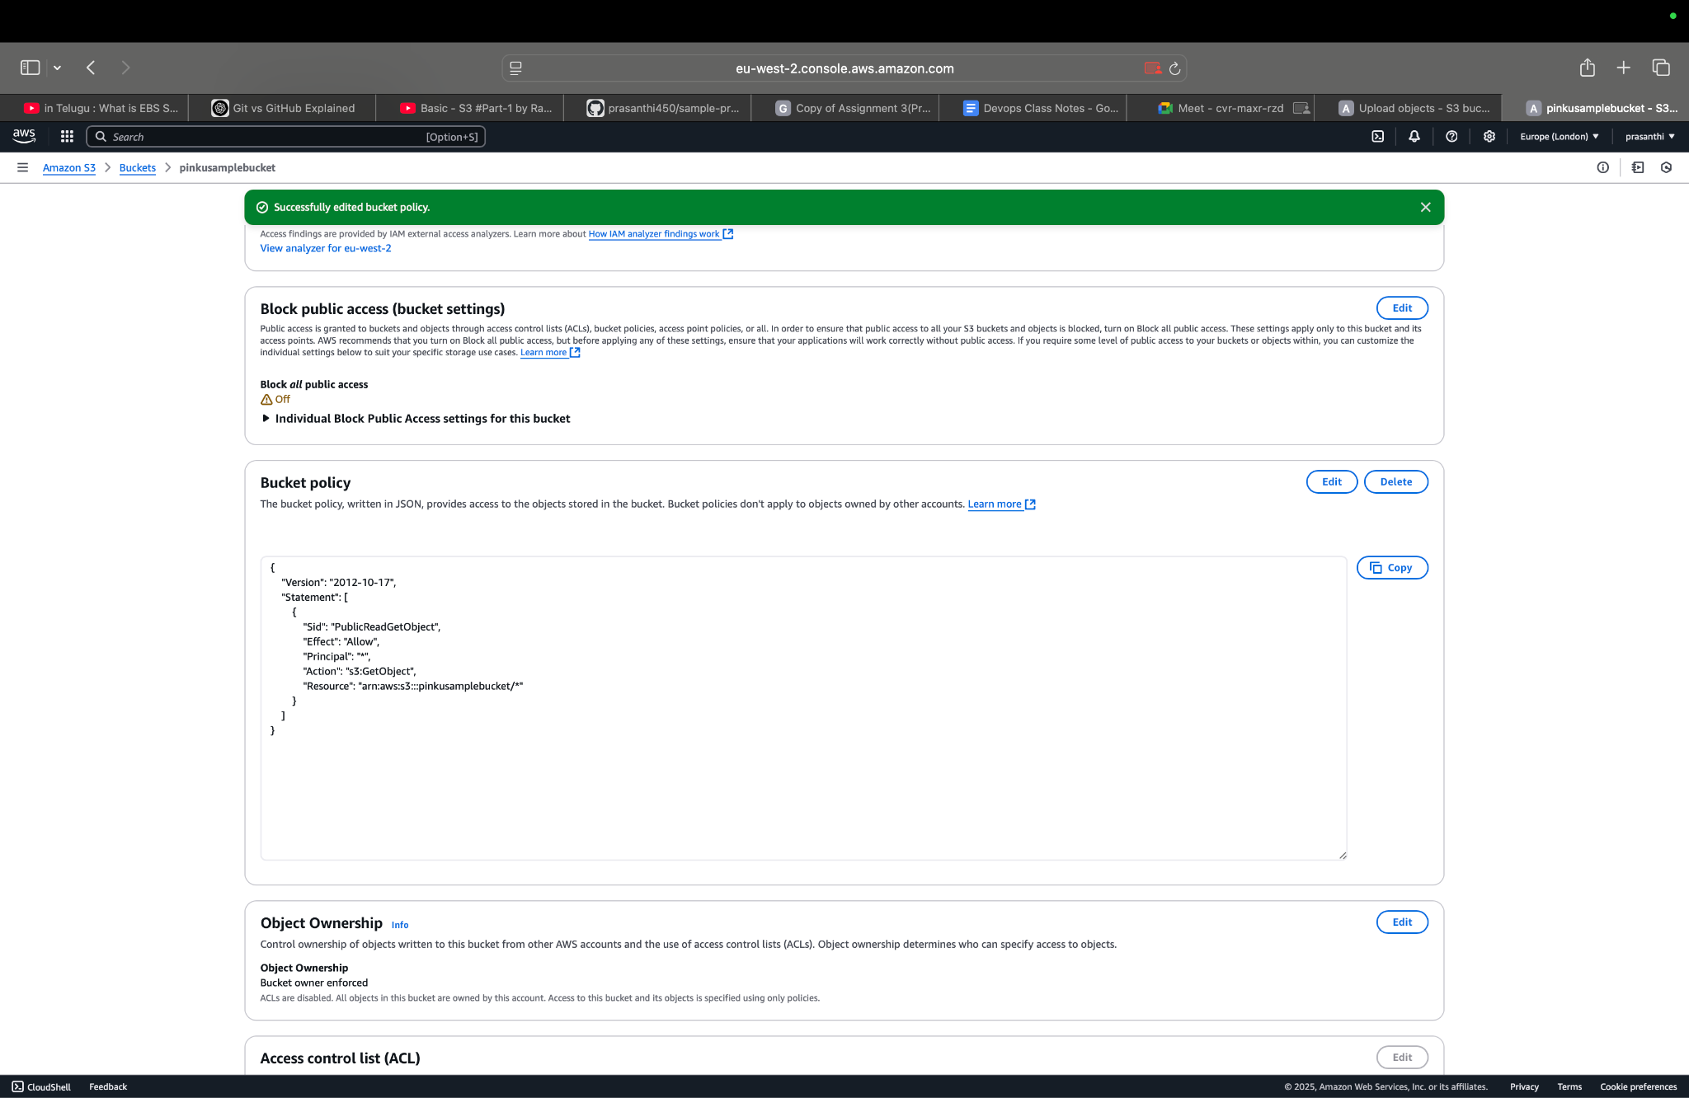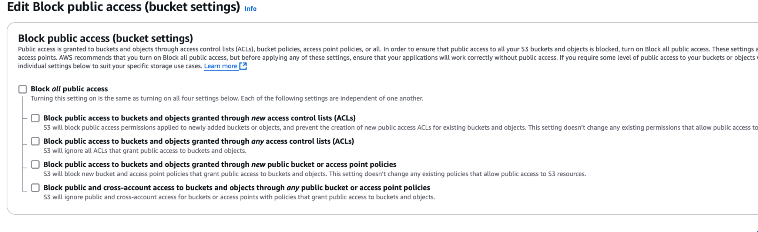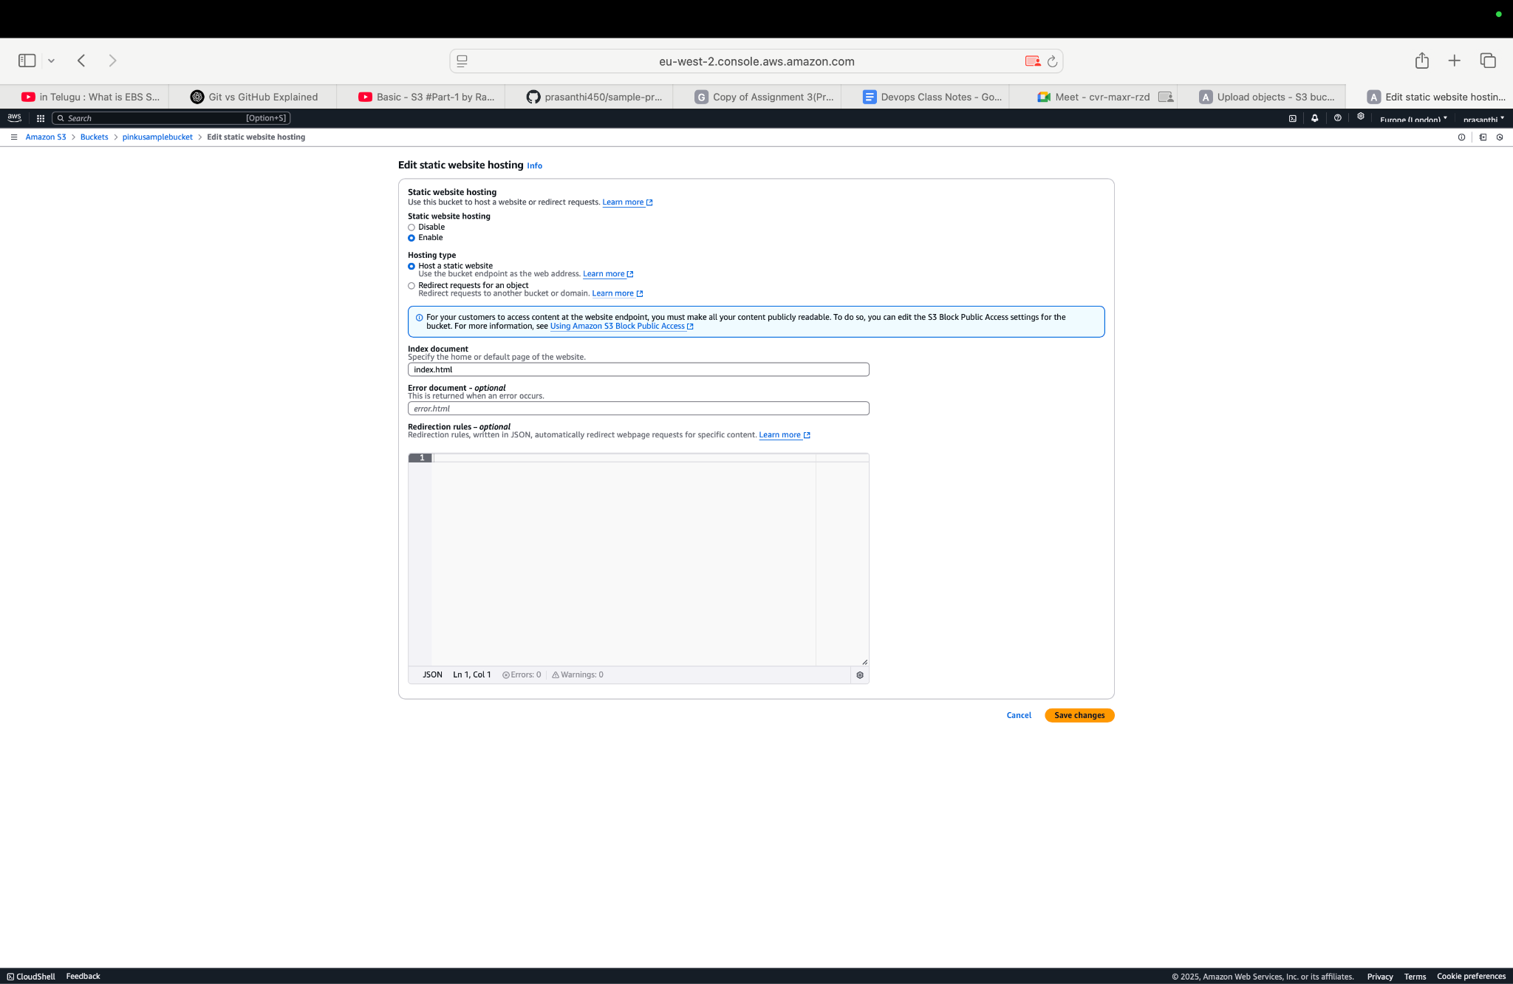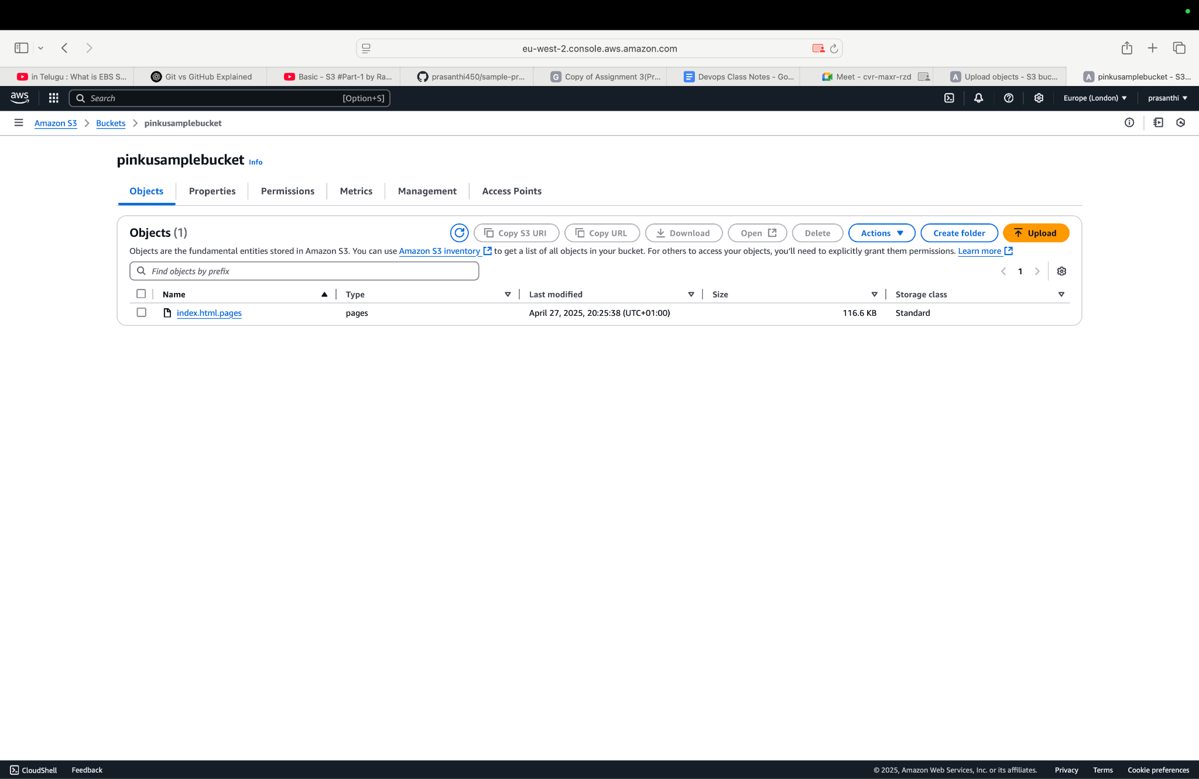
- What are the major differences between S3 Standard Storage Class and S3 Glacier Storage Class?
S3 Standard is used for data you need to access often, with fast access speed but higher storage cost.
S3 Glacier is used for data you rarely access, with very low storage cost but much slower retrieval times and extra retrieval costs.

Section 4: Shell Scripting - Nginx Setup (2 Questions)
- Write a shell script that installs nginx on an Ubuntu EC2 instance and sets up two websites (site1.com and site2.com) using different server blocks (virtual hosts).
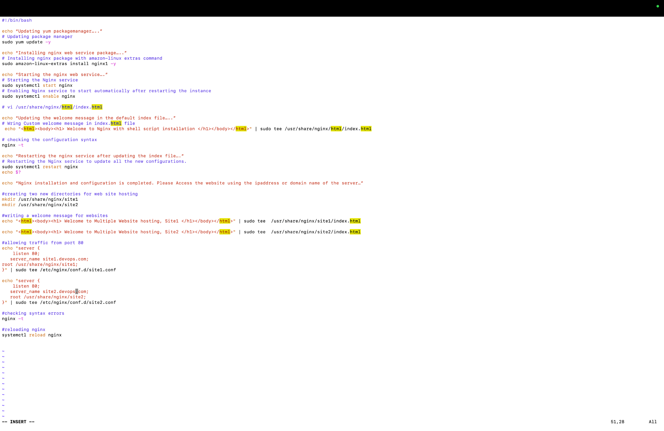
- What changes would you need to make to ensure that nginx starts automatically after server reboot?
- (Mention enabling services.) sudo systemctl enable nginx.

Section 5: AWS AMIs and Volume Snapshots (2 Questions)

- Explain the steps to create an Amazon Machine Image (AMI) from an existing EC2 instance.
Ans: Select EC2 → Create Image → Name and Configure → Create AMI → Launch from AMI. AMIs allow you to quickly replicate EC2 instances with the same setup.

- What are EBS volume snapshots? How can you automate regular snapshots for backup purposes?
Ans: EBS Snapshots: Point-in-time backups of your EBS volumes, stored in S3. Automation:Use Lifecycle Manager or AWS Backup to automate regular snapshots for backup purposes.

📅 Final Submission Task:
- Upload all your answers in a single folder.
- Include your shell script separately.
- Push your work to GitHub.
- Raise a Pull Request to the following repository:
✨ Repository URL: https://github.com/Kloudvidhya/assignments.git

Good Luck! 🌟
#DevOps #AWS #GitHub #Kloudvidhya

